# L11_Unit3: Travel

<https://ec.ef.com.cn/school/studyunit#school/2505ece3-f653-4a2f-9edb-1fc969b4bae8/2505ece3-f653-4a2f-9edb-1fc969b4bae8/5a302b42-de29-4aaf-a125-9d0e1895a570/57a52808-afdd-4205-a2e4-b1c299793b7c/c8c4c0c4-08a4-40b1-9c59-062813aba424>

# Lexical

|  |
| --- |
| //cleft:   1. a natural crack/rift/fissure in something, especially the surface of rocks or the Earth 〔地球或岩石表面的〕裂缝，裂口 a narrow cleft in the rocks too small for humans to enter.   ...石块上一个对于人想钻进来说太小了的裂口。 2. [N-COUNT](javascript:;)A cleft in someone's chin is a line down the middle of it. (下巴上的)裂纹; 3. [ADJ](javascript:;)If someone has [**a cleft chin]**, they have an area on the chin or lip that goes slightly inwards 〔下巴或嘴唇上的〕凹痕，凹口;兔唇      1. [cleft sentence ] e.g. **What** I **love** is looking at modern architecture |
| Words that end in **-ing** often describe a feature of something, **whereas相比之下** words that end in **-ed** describe feelings or emotion |
| Soften  ['sɔfn] negative remarks  |  |  | | --- | --- | |  | | | You never know who will read your blog post, so if you are going to say something negative about someone's city, you should be **diplomatic** (diplomatic). **One way is to preface it with a clause that softens your opinion.** | | |  |  | | **I hate to say it,** **but <xxx, e.g.** homelessness> is a problem there. |  | |  |  | | **I don't want to offend anyone, but <xxx, e.g.** crime> was a problem there. |  | |  |  | | **I'm sorry to say this, but** it was disgusting. |  | |  |  | | e.g. Norman, I basically agree with you that Barcelona is an amazing city, but there is one negative. The city has a high unemployment rate, which has caused a bit of an increase in the crime rate. **I hate to say it/I don’t wanna offend you, but** if you're a tourist, you have to be careful about pickpockets. Of course, every large city with tourists has the same problem. Other than that, I think Barcelona IS one of the best cities in the world – magnificent architecture, friendly people and incredibly various cuisines and delicious food. | | | Another way to soften a negative opinion is to use qualifiers like **a little** or **a bit**. | | |  |  | | It was **a little** disgusting. |  | |  |  | | She was **a bit** disturbed. |  | |
| vibrant /ˈvaɪbrənt/   1. [ADJ](javascript:;)Someone or something that is vibrant is full of life, energy, and enthusiasm. 充满活力的   •  Tom felt himself being drawn toward her vibrant personality.   汤姆感到自己正被她充满活力的个性所吸引。  •  ...Shakespeare's vibrant language.   …莎士比亚那充满活力的语言。   1. [N-UNCOUNT](javascript:;)活力   •  She was a woman with extraordinary vibrancy and extraordinary knowledge.   她是一个活力四射、知识渊博的女性。   1. [ADJ](javascript:;)**Vibrant colours** are very bright and clear. (色彩) 鲜亮的   •  Horizon blue, corn yellow and pistachio green are just three of the vibrant colours in this range.   天际蓝、玉米黄和淡草绿只是这一色域中的3种鲜亮色彩。   1. [ADV](javascript:;)鲜亮地   •  ...a selection of vibrantly coloured French cast-iron saucepans.   …一套精选的色彩鲜亮的法国铸铁炖锅。 |
| **恶劣的; 狂风暴雨的〔天气〕  [inclement weather] is unpleasantly cold, stormy, wet, rainy etc**  e.g. Have your airline phone numbers stored on your cellphone. This is very important because the first thing you want to do when you hear your flight has been canceled is to call the airline immediately. Of course, everyone else will also be calling, so expect to **be placed on hold**. If your flight is canceled due to **inclement weather**, many flights may also be canceled, and the call center representatives will be flooded with calls. But if you **are placed on hold**, just wait patiently. |
| /ˈkiːɒsk/ kiosk: is a small structure with an open window at which people can buy things like newspapers, pay an attendant at a parking lot, or get information about something. (出售报刊、停车收费或问讯的) 亭子  •  I was getting cigarettes at the kiosk.   我正在书报亭买烟。  •  ...an information kiosk.   …一个问讯亭。  E.g. Get in line to rebook, as suggested by the airline, but stay online with the airline call center. Talk with whomever can take care of you first. Also, some airports have special **kiosks** for **self-service rebooking自助预定**.   * V.S**. treacherous** /ˈtrɛtʃərəs/; treacherously**adv**   1. [ADJ](javascript:;)If you describe someone as treacherous, you mean that they are likely to betray you and cannot be trusted; because they are not loyal and secretly intend to harm you 背信弃义的; 不忠阴险的 **[ a treacherous person: 背信弃义的人]**  •  He publicly left the party and denounced its **treacherous leaders背信弃义的领导人们**。  • a treacherous plot/conspiracy to **overthrow the government** 一个推翻政府的阴谋   * 2. 暗藏危险的, 变化莫测的〔地面情况、道路情况、天气情况等〕 ground, roads, weather conditions etc that are treacherous are particularly dangerous because you cannot see or predict the dangers very easily**. [ treacherous roads; treacherous weather]**   • treacherous mountain roads 危险重重的山路  • Strong winds and loose rocks made climbing treacherous. 大风和松动的岩石使登山充满险阻。 |
| **[ be placed on hold] 把事情都准备好**  e.g. Have your airline phone numbers stored on your cellphone. This is very important because the first thing you want to do when you hear your flight has been canceled is to call the airline immediately. Of course, everyone else will also be calling, so expect to **be placed on hold**. If your flight is canceled due to **inclement weather or treacherous weather (**inclement weather is unpleasantly cold, wet, foggy, frozen cold, etc〔天气〕恶劣的；寒冷的；多雨的), many flights may also be canceled, and the call center representatives will be flooded with calls. But if you **are placed on hold把事情都准备好**, just wait patiently. |
| **It doesn’t hurt to do sth: 做xxx事情又不会少块肉**  **e.g. [ It never hurts to ask for assistance, as long as you ask politely]**  e.g. Regulations about what airlines are required to offer customers vary widely. However, in general, if the situation is beyond the airline's control (weather, air-traffic delays), you probably won't be offered compensation or assistance. If the situation is within the airline's control (maintenance problem, lack of a flight crew), you probably will be given some compensation, like meal or hotel vouchers. Remember, though, **it never hurts to ask for assistance, as long as you ask politely做xxx事情又不会少块肉.** |
| **[美国俚语]** [**背黑锅**](javascript:;)**; 承担分外的责任；(为别人)受责备；(为别人)受惩罚: take the rap**   1. When these things go wrong , the government tends to **take the rap**.  这类事情出错时，政府总是会受到指责。 2. But Mr Abhisit knows that in the calculus of Thailand’s political demonstrations, his governmentwould be likely to **take the rap** for a bloody confrontation, were anyone to overreact.  他的政府很可能因血腥镇压而备受责难。  替罪羊 scapegoat **/ˈskeɪpˌɡəʊt/** 1. [N-COUNT为xxx充当替罪羊:](javascript:;)If you say that **someone is made a scapegoat for something** bad that has happened, you mean that people blame them and may punish them for it although it may not be their fault. In other words, they **take the rap**[**背黑锅**](javascript:;)**; (为别人)受责备；(为别人)受惩罚**•  e.g. I don't think I deserve to **be made the scapegoat for** a couple of bad results.  我认为我不该为出现的一些不良后果充当替罪羊。  2. [V-T](javascript:;)**使sb.成为替罪羊**: To **scapegoat someone** means to blame them publicly for something bad that has happened, even though it was not their fault. In other words, that person **take the rap**[**背黑锅**](javascript:;)**; (为别人)受责备；(为别人)受惩罚**•  e.g.  ...a climate where ethnic minorities are continually scapegoated for the lack of jobs and housing problems.  …一种屡屡把缺少工作职位和住房问题归罪于少数族裔的风气。 |
| Ask for clarification and Confirmation       * So, you’re saying that xxx * So, **let me get this straight**. xxx * So, you mean that xxx * So does it mean that xxx |
| ['plætɪnəm,'plætənəm] platinum   1. a silver-grey metal that does not change colour, doesn’t **tarnish 发乌**, or lose its brightness, and is used in making expensive jewellery, like ring. And in chemistry industry. It is a chemical element: symbol Pt 铂/白金〔一种化学元素，符号为Pt〕**e.g. a platinum ring 白金戒指** 2. 专辑唱片达到了白金销量if “**a music album goes platinum / plætənəm /”,** at least a million copies of it have been sold 白金销量〔唱片销量至少达一百万张〕 E.g. EXO, one of the most famous Boy bands in South Korea, their albums **went platinum** . 专辑唱片达到了白金销量。•a platinum disc 一张白金唱片 |
| Mile+age => mileage /ˈm**aɪlɪ**dʒ/   1. [N-UNCOUNT](javascript:;)Mileage refers to the distance that you have travelled, measured in miles. 英里里程   •  While most of their mileage may be in and around town, they still want motorways for longer trips.   他们大多数的行程可能都在城里或城周围，可是他们仍然需要适合长距离旅行的高速公路。   1. [N-UNCOUNT](javascript:;)The mileage of a vehicle is the number of miles that it can travel using one gallon or litre of fuel. (耗油1加仑或1升可行驶的) 英里里程   •  They are willing to pay up to $500 more for cars that get better mileage.   他们愿意多付$500来买单位汽油里程数更高的汽车。   1. [N-UNCOUNT](javascript:;)The mileage in a particular course of action is its usefulness in getting you what you want. 好处   •  It's obviously important to get as much mileage out of the convention as possible.   从契约中得到尽可能多的好处显然很重要 |
| make up sb’s mind = make a decision  make up sb’s mind to do = decide to do |
| **对(某个国家，某人)**[**进行访问**](javascript:;)**；**[**拜访**](javascript:;) **[ pay a visit to a country; pay a visit to sb. ]**  e.g. 会访问白宫: pay a visit to White House  e.g. The Russian leader will **pay a visit to the White House** 访问白宫 before both men go to Lisbon for the NATO summit. |
| sightsee ['saɪtsi] v. 观光；游览[V](javascript:;)to visit the famous or interesting sights of (a place) ; when you visit famous or interesting places, especially as tourists 〔尤指游客的〕观光，游览  N.) ['saɪt‚siːɪŋ] sightseeing: [N-UNCOUNT](javascript:;)If you go sightseeing or do some sightseeing, you travel around visiting the interesting places that tourists usually visit. 观光  **[观光: go sightseeing ; 观光巴士；游览巴士: sightseeing bus]**  e.g. She swam and sunbathed, **went sightseeing** and relaxed.  e.g....a day's sight-seeing in Venice.  …在威尼斯的一日游。  e.g. I wanna take that famous **sightseeing bus** (Duck boat) to travel around Singapore.  e.g. |
| ['dʒətlæg] jet + lag = jetlag n. 时差综合症（跨时区高速飞行后生理节奏的破坏）   * Jet = plane * Lag behind |
| **I'm thinking of** visiting Vancouver.  **I'm hoping to** see Paris.  I i**ntend to** spend five days.  **I'm planning to** visit Moscow.  I've **made up my mind. =** I have **made my decision .** |
| /aɪˈtɪnərərɪ/ itinerary: [N-COUNT](javascript:;)An itinerary is a plan of a trip, including the route and the places that you will visit. The itinerary is usually needed when you need to apply for a VISA to visit another country.旅行计划 **[ 制定旅行计划: work out an itinerary ]**  e.g. The next place on our itinerary was Sedona.  我们旅行计划的下一站是塞多纳  e.g I’ve got to **work out a rough itinerary** to apply for U.S. travelling VISA. |
| = itinerary    // I'm planning **to hit all the big cities.** |
|  |

# Part1) Plan a trip











 = itinerary



// I'm planning **to hit all the big cities.**

 // I **intend to** go for about two weeks.







//make up sb’s mind to do; //get some sightseeing done.

// sightsee ['saɪtsi] v. 观光；游览[V](javascript:;)to visit the famous or interesting sights of (a place) 观光

['saɪt‚siːɪŋ] sightseeing N.) when you visit famous or interesting places, especially as tourists 〔尤指游客的〕观光，游览 [ go sightseeing ] She swam and sunbathed, went sightseeing and relaxed.











## Making plans

|  |  |  |
| --- | --- | --- |
|  | | |
| Use these expressions to talk about a **tentative plan 初步的未最终确定的计划**. After the verb **think**, you can use **about** or **of**. | | |
|  | |  |
|  |  |  |

|  |  |  |
| --- | --- | --- |
|  | **I'm thinking about** visiting Korea. **My plan is still rather rough/tentative**. |  |
|  |  |  |

|  |  |  |
| --- | --- | --- |
|  | **I'm hoping to** go to Brazil this August. |  |
|  |  |  |
| Use these expressions for plans that are firmer. | | |
|  | |  |
|  |  |  |

|  |  |  |
| --- | --- | --- |
|  | **I intend to** spend five days in Cancun, Mexico. |  |
|  |  |  |

|  |  |  |
| --- | --- | --- |
|  | **I'm planning to** visit Tokyo and Kyoto. |  |

|  |
| --- |
| **I'm thinking of** visiting Vancouver.  **I'm hoping to** see Paris.  I i**ntend to** spend five days.  **I'm planning to** visit Moscow.  I've **made up my mind. =** I have **made my decision .** |
| /aɪˈtɪnərərɪ/ itinerary: [N-COUNT](javascript:;)An itinerary is a plan of a trip, including the route and the places that you will visit. The itinerary is usually needed when you need to apply for a VISA to visit another country.旅行计划 **[ 制定旅行计划: work out an itinerary ]** |

## Making decisions

|  |  |  |
| --- | --- | --- |
|  | | |
| When you have **made a firm decision**, you can use expressions like these: | | |
|  | |  |
|  |  |  |

|  |  |  |
| --- | --- | --- |
|  | **I've made up my mind.** I'm going to Egypt! |  |
|  |  |  |

|  |  |  |
| --- | --- | --- |
|  | **I've finally made my decision.** I'm going to Russia. |  |

## Making recommendations

|  |  |  |
| --- | --- | --- |
|  | | |
| Here are some ways to make recommendations. Generally, the shorter the expression, the more direct the recommendation is. | | |
|  | |  |
|  |  |  |

|  |  |  |
| --- | --- | --- |
|  | **I would highly recommend that** you make a detailed itinerary for applying for the U.S. travelling VISA. |  |
|  |  |  |

|  |  |  |
| --- | --- | --- |
|  | **It would be a good idea** to spend more time in Osaka. I highly recommend you enjoying the cherry blossom樱花 in Osaka Park. |  |
|  |  |  |

|  |  |  |
| --- | --- | --- |
|  | **One thing that you might consider is** going in September. |  |

|  |  |  |
| --- | --- | --- |
| **Negative recommendations** | | |
| Here are some ways to make negative recommendations. As with positive recommendations, shorter expressions are generally more direct. | | |
|  | |  |
|  |  |  |

|  |  |  |
| --- | --- | --- |
|  | **I don't recommend** seeing four cities in a week. |  |
|  |  |  |

|  |  |  |
| --- | --- | --- |
|  | **If I were you, I wouldn't** go to Nice later in the year. 🡺 **subjunctive mood,  [səb'dʒʌŋktɪv] 虚拟语气** |  |
|  |  |  |

|  |  |  |
| --- | --- | --- |
|  | **I'm really not sure that** staying only in Osaka **is a good idea**. |  |
|  |  |  |
| One way to give negative feedback is to **preface it with a positive statement**. Notice the use of the word **but**. | | |
|  | |  |
|  |  |  |

|  |  |  |
| --- | --- | --- |
|  | I **generally** really like your itinerary/plan/proposal, **but** there is just one problem. |  |

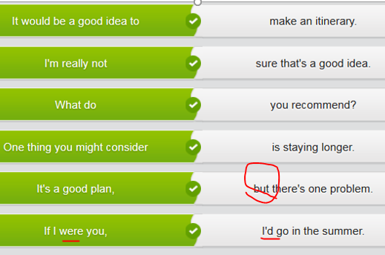

## Travel plan/Itinerary

|  |
| --- |
| TED: I've finally decided where I'm going on vacation this summer. SUE Really? Where? TED Japan! I've **made up my mind**. Now I just need your help with my itinerary. I know you've been there a few times for business. SUE Yes, and it's a great place to visit. What do you want to see? Temples? Gardens? Cities? The countryside? TED Cities, temples and shopping areas. **I'm hoping to** spend some time in Tokyo, but most of my time in Kyoto. SUE That's a good plan. How long will you be there? TED I'll have five days there. SUE Just five days? Are you crazy? **It would be a good idea** to spend at least seven days there. TED Hmm. I'll consider it. So, if I have a week there, how much time should I spend in each city? SUE **I recommend** three days in Tokyo. You can see the famous temples, visit a museum and go to the main shopping areas**. If I were you, I'd** spend the rest of the time in Kyoto. It's a smaller city, and you'll get a feel for the more traditional Japan. TED Great idea. I'll **work out my itinerary** and send it to you in a few days. SUE Sure. Glad to help you. TED Thanks! |

# Part2) Book a ticket by phone























Ｕｇｈ,　Do you have a **direct flight** instead of the **stopover flight中途停留；**

**//** TRACY: Let me just check the schedule... Yes, we have a flight on the 21st, departing 10am and arriving at 16:45pm. There’s also a cheaper flight with a **stopover** in Berlin, departing at 10.15am and arriving in Moscow at 18.05pm. Would you like to make a reservation?  
  
MATTHEW: Yes, please. I’ll take the **direct** flight.









//mileage ['maɪlɪdʒ] n. 英里数





Sounds cool.





Or “ ***Let me get this straight让我把这件事情弄清楚. Is it 15 or 50?”***





















## Basic flight information

|  |  |  |
| --- | --- | --- |
|  | | |
| To arrange a trip, you need to be able to discuss basic information about your flight. This includes information about dates, your destination, layovers and what class ticket you want. | | |
|  | |  |
|  |  |  |

|  |  |  |
| --- | --- | --- |
|  | *My* ***departure date*** *is May 21st. I'll* ***return*** *on June 6th.* |  |
|  |  |  |
|  |  |  |
|  |  |

|  |  |  |
| --- | --- | --- |
|  | A: *OK. So you're* ***leaving from*** *Paris. What's your* ***destination****?* |  |
| B: *Rio de Janeiro.* |  |
|  |  |  |
|  |  |  |
|  |  |

|  |  |  |
| --- | --- | --- |
|  | You have a three-hour ***layover***in Rome. |  |
| B: *That's too bad. I'd rather have a* ***direct flight****.* |  |
|  |  |  |
|  |  |  |

|  |  |  |
| --- | --- | --- |
|  | *I wanted to fly* ***first class*** *or* ***business class****, but I'll be in* ***economy****.* |  |
|  |  |  |
|  |  |  |

|  |  |  |
| --- | --- | --- |
|  | *I want to* ***upgrade*** *to business class.* | . |
|  |  |  |
|  |  |  |

|  |  |  |
| --- | --- | --- |
|  | *England Airways is an* ***affiliated*** *airline of Eastern Airways. //CNN* ***affiliated*** *news agent* |  |

|  |  |  |
| --- | --- | --- |
| **Basic passenger information** | | |
| If you have an account with the airline, you will need to discuss that along with any special status – for example, **gold** (gold) or **platinum** (platinum). If you fly on an **affiliated** (affiliated) airline, you will still get your frequent-flyer miles. | | |
|  | |  |
|  |  |  |

|  |  |  |
| --- | --- | --- |
|  | *I have almost 50,000* ***frequent-flyer miles****.* |  |
|  |  |  |
|  |  |  |

|  |  |  |
| --- | --- | --- |
|  | *I'm* ***platinum status*** *now.* |  |

***// platinum****/ˈplætɪnəm/****? Platinum is a very valuable, silvery-grey metal. It is often used for making jewellery. 铂; 白金 ; 白金销量〔唱片销量至少达一百万张〕***

## Ask for clarification

|  |  |  |
| --- | --- | --- |
|  | | |
| When you're listening to detailed information, it's critical that you clarify anything you don't understand. You can tell the person that you don't understand, ask them to speak more slowly or ask for repetition. | | |
|  | |  |
|  |  |  |

|  |  |  |
| --- | --- | --- |
|  | ***I'm not following you****. Could you plz repeat it?* | . |
|  |  |  |

|  |  |  |
| --- | --- | --- |
|  | ***I didn't catch that****. Could you repeat it?* |  |
|  |  |  |

|  |  |  |
| --- | --- | --- |
|  | ***I didn't understand what you said.*** *Did you say 15 or 50?* |  |

## Confirm information

|  |  |  |
| --- | --- | --- |
|  | | |
| When you think you understood what someone said, but you're not completely sure, **confirm** (confirm) the information. | | |
|  | |  |
|  |  |  |
|  |  |

|  |  |  |
| --- | --- | --- |
|  | A:***So, you're saying所以，你是说***  *if I pay an extra $200 bucks, I can upgrade to economy plus?* |  |
| B: *Yes, that's right.* |  |
|  |  |  |
|  |  |  |
|  |  |

|  |  |  |
| --- | --- | --- |
|  | A:***Let me get this straight让我把这件事情弄清楚；让我捋直这件事.*** *The total* ***flight time*** *is 10 hours?* |  |
| B: *No, I'm sorry. It's actually 16 hours, including* ***6-hr layover in Seoul****.* |  |
|  |  |  |
|  |  |  |
|  |  |

|  |  |  |
| --- | --- | --- |
|  | A:***Let me make sure I understand.*** *You want to leave on the 21st and return on the 30th?* |  |
| B: *Yes, that's correct.* |  |

 A: ***If I’m hearing you correctly, that’s 15 not 50, right?***

# Part3)

Be due to xxx = because of xxx

It's been delayed **because of** a security threat

There's a mechanical problem

They're having maintenance issues.

Your flight now departs at 6 p.m.

## Rebook a flight

 









Do you remember your flight No ,sir?





Yes





























OK, sir, I’m sorry for the inconvenience.



That sounds great!



We **rebooked you** on the same flight tomorrow.

## Tips for flying

If you fly anywhere these days, you have probably experienced the unfortunate situation of a canceled flight. Here are some tips on how to deal with this increasingly common airline experience.

1. Plan ahead. If possible, try to fly nonstop. Nonstop means there is less chance of a cancellation or delay, so you can get to your destination on time.

2. Fly early in the day. If your flight is canceled or delayed, you have more options for being rebooked on a later flight. If you are on one of the last flights of the day, you will be in trouble if that flight is canceled.

3. Pack lightly. If possible, just have **carry-on baggage**. It's much easier to reschedule a flight if you haven't checked bags. //**check-in luggage** V.S. **carry-on luggage**手提行李

4. Have your airline phone numbers stored on your cellphone. This is very important because the first thing you want to do when you hear your flight has been canceled is to call the airline immediately. Of course, everyone else will also be calling, so expect to **be placed on hold**. If your flight is canceled due to **inclement weather (**inclement weather is unpleasantly cold, wet etc〔天气〕恶劣的；寒冷的；多雨的), many flights may also be canceled, and the call center representatives will be flooded with calls. But if you **are placed on hold**, just wait patiently.

5. Get in line to rebook, as suggested by the airline, but stay online with the airline call center. Talk with whomever can take care of you first. Also, some airports have special **kiosks** for **self-service rebooking自助预定**. // is a small structure with an open window at which people can buy things like newspapers, pay an attendant at a parking lot, or get information about something. (出售报刊、停车收费或问讯的) 亭子

6. Be polite to **the ticket agent** or call center agent. Your problem isn't the fault of that person. You can even say something like 'I know it's not your fault, but I'm not happy right now because …' Rude or demanding passengers will likely **end up with less**. This is a situation where politeness and courtesy can make all of the difference.

7. Regulations about what airlines are required to offer customers vary widely. However, in general, if the situation is beyond the airline's control (weather, air-traffic delays), you probably won't be offered compensation or assistance. If the situation is within the airline's control (maintenance problem, lack of a flight crew), you probably will be given some compensation, like meal or hotel vouchers. Remember, though, **it never hurts to ask for assistance, as long as you ask politely**.

# Part4) Describe a city that you visited (IELTS oral topic)



Thank you, Mike. I’ts amazing. And I’ve got sth for you.







OK, great



*  // [mə'mɔːrɪəl]



yes

yea..

















 //help sb. out.

 



 //stop by <a place> 顺便去趟

 Had the pizza.

 => I love it, every single night



## Positive features of a city

|  |  |  |
| --- | --- | --- |
|  | | |
| World-class cities have many attractive features you'll want to include in your writing. | | |
|  | |  |
|  |  |  |

|  |  |  |
| --- | --- | --- |
|  | *Paris has* ***magnificent architecture****.* |  |
|  |  |  |
|  |  |  |

|  |  |  |
| --- | --- | --- |
|  | *San Francisco has* ***stunning views*** *of the bay and hills. //a stunning beauty* |  |
|  |  |  |
|  |  |  |

|  |  |  |
| --- | --- | --- |
|  | *Singapore has so much* ***cultural diversity****.* |  |
|  |  |  |
|  |  |  |

|  |  |  |
| --- | --- | --- |
|  | *Rome has amazing* ***ancient monuments****.* |  |
|  |  |  |
|  |  |  |

|  |  |  |
| --- | --- | --- |
|  | *Shanghai has a* ***vibrant art scene****.* |  |

## Negative features of a city

|  |  |  |
| --- | --- | --- |
|  | | |
| Unfortunately, large urban areas often have serious social and economic problems. | | |
|  | |  |
|  |  |  |

|  |  |  |
| --- | --- | --- |
|  | ***Unemployment*** *is really high in Chicago.* |  |
|  |  |  |
|  |  |  |

|  |  |  |
| --- | --- | --- |
|  | *Tampa has a terrible problem with* ***homelessness****.* |  |
|  |  |  |
|  |  |  |

|  |  |  |
| --- | --- | --- |
|  | *There is a lot of* ***crime*** *in most huge cities.* |  |
|  |  |  |
|  |  |  |

|  |  |  |
| --- | --- | --- |
|  | *I hate seeing* ***trash*** *on the streets of my city.* |  |

## Describe a city

|  |  |
| --- | --- |
|  | |
| One way to write an interesting city description is to use a variety of descriptive words to communicate your emotions. Be careful with the **-ing** and **-ed** word endings.  Words that end in **-ing** often describe a feature of something, **whereas相比之下** words that end in **-ed** describe feelings or emotion. | |
|  |  |
| *The homelessness in Tampa was* ***shocking****.* | The homelessness in Tampa was **shocking**. |
|  |  |
| *I was* ***shocked*** *by the homelessness in Tampa.* | I was **shocked** by the homelessness in Tampa. |
|  |  |
|  | |
| Here are a few more pairs of descriptive words. | |
|  |  |
| *disgusted – disgusting* |
| *amazed – amazing* |
| *disturbed – disturbing* |
| *confused – confusing* |
| *surprised – surprising* |

## Soften  ['sɔfn] negative remarks

|  |  |
| --- | --- |
|  | |
| You never know who will read your blog post, so if you are going to say something negative about someone's city, you should be **diplomatic** (diplomatic). **One way is to preface it with a clause that softens your opinion.** | |
|  |  |
| ***I hate to say it,*** *but homelessness is a problem there.* |  |
|  |  |
| ***I don't want to offend anyone, but*** *crime was a problem there.* |  |
|  |  |
| ***I'm sorry to say this, but*** *it was disgusting.* | **I'm sorry to say this, but** it was disgusting. |
|  |  |
|  | |
| Another way to soften a negative opinion is to use qualifiers like **a little** or **a bit**. | |
|  |  |
| *It was* ***a little*** *disgusting.* | It was **a little** disgusting. |
|  |  |
| *She was* ***a bit*** *disturbed.* | She was **a bit** disturbed. |

## **Cleft sentences** for emphasis

//cleft:

1. a natural crack/rift/fissure in something, especially the surface of rocks or the Earth 〔地球或岩石表面的〕裂缝，裂口
2. a narrow cleft in the rocks too small for humans to enter.   
    ...石块上一个对于人想钻进来说太小了的裂口。
3. [N-COUNT](javascript:;)A cleft in someone's chin is a line down the middle of it. (下巴上的)裂纹; [ADJ](javascript:;)If someone has a cleft chin, they have a cleft in their chin. (下巴)裂的; an area on the chin or lip that goes slightly inwards 〔下巴或嘴唇上的〕凹痕，凹口;兔唇

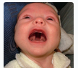

|  |  |  |
| --- | --- | --- |
|  | | |
| Sometimes speakers and writers want to focus attention on a particular thing or idea. One way to do that is to change the order of a sentence. In some grammar books, this is referred to as a **cleft sentence** (cleft sentence). Here are some examples: | | |
| **Starting a sentence with 'what'** | | |
| Compare the two sentences. Notice in the second sentence the heavy stress on the word **love**, and it begins with the word **what** | | |
|  | | |
|  |  |  |

|  |  |  |
| --- | --- | --- |
|  | *I love looking at modern architecture.* | I love looking at modern architecture. |
|  |  |  |
|  |  |  |

|  |  |  |
| --- | --- | --- |
|  | ***What*** *I* ***love*** *is looking at modern architecture.* | What I love is looking at modern architecture. |

Despite their complexity, these sentences are quite common in English. They are a good **way to emphasize something particular in a sentence.** Look at the next pairs of regular and reordered sentences and compare the stress levels.

|  |  |  |
| --- | --- | --- |
|  | *It is interesting how the city has changed.* |  |
|  |  |  |
|  |  |  |

|  |  |  |
| --- | --- | --- |
|  | *What is interesting is how the city has changed.* | What is interesting is how the city has changed. |
|  |  |  |
|  |  |  |

|  |  |  |
| --- | --- | --- |
|  | *I like the efficient subways in Tokyo.* | I like the efficient subways in Tokyo. |
|  |  |  |
|  |  |  |

|  |  |  |
| --- | --- | --- |
|  | *What I like about Tokyo is the efficient subways.* | What I like about Tokyo is the efficient subways. |
|  |  |  |
|  |  |  |

|  |  |  |
| --- | --- | --- |
|  | *I'm interested in shopping.* | I'm interested in shopping. |
|  |  |  |
|  |  |  |

|  |  |
| --- | --- |
|  | *What I'm interested in is shopping* |

## Best Cities in the World

by Norman Nomad / May 26

I just returned from Barcelona/SH/Singapore/Seoul, and I have to say that it's the most wonderful city in the world! The architect Antoni Gaudi built some of the most **stunning** buildings I've ever seen. The view from his Parc Guell is amazing. Barcelona is **culturally diverse**, with artists from all over the world creating a vibrant生气勃勃的 art scene. The city officials are working hard to help the homeless and to keep the city clean. I can't think of anything negative to say about Barcelona.

**1 comment**

Daphne

Norman, I basically agree with you that Barcelona is an amazing city, but there is one negative. The city has a high unemployment rate, which has caused a bit of an increase in the crime rate. **I hate to say it/I don’t wanna offend you, but** if you're a tourist, you have to be careful about pickpockets. Of course, every large city with tourists has the same problem. Other than that, I think Barcelona IS one of the best cities in the world – magnificent architecture, friendly people and incredibly various cuisines and delicious food.

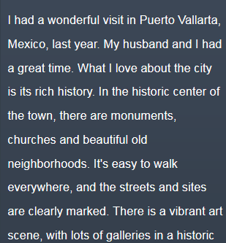 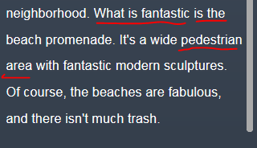

* Think the “Pedestrian street” in Seoul 林阴道步行街

# **Unit title: Travel English**

<https://ec.ef.com.cn/school/studyunit#school/0a027417-6c4c-433e-ae9f-bce0767e603e/0a027417-6c4c-433e-ae9f-bce0767e603e/33bcfe47-2acd-414c-8dcd-2d8a4d811609/e61b1562-469a-4ada-ad4d-2217585bc05a>

# Stop) CNN related news about xxx

# Part 1)

## Stop) Lexical resource

## 1st row)

## Not mp3 Video) Find your hotel











Excuse me, 





Thanks for your help. You’re welcome.





e.g. Hi, my name is Tracy and I have a reservation😊





It’s across the street.





# Part 2) Booking a flight

## STOP** Lexical resources

* /klɑːk,klɝk/ clerk  
  1.someone whose job is to help people in a shop 〔商店的〕售货员，店员 •the clerk in the shoe store 鞋店售货员  
  2.someone whose job is to help people when they arrive at and leave a hotel 〔旅店的〕接待员 **[ the desk clerk酒店柜台服务员 ]**Leave the keys with the desk clerk . 把钥匙交给 酒店柜台服务员
* 酒店的早晨叫醒服务  
  e.g. Can I have **a wake-up call**? = I’d like a wake-up call, is it OK?   
  e.g. What time does he want his **wake-up call**?
* [ Could you tell me how to get to the xxx] e.g. Tourist: Excuse me. Could you help me, please? **Could you tell me how to get to the** museum, please?  
    
  Passerby: Yes, no problem**. e.g. Go straight down** the Main Street and **take the 2nd left/right.** Then **keep going ahead** till you pass a Chinese restaurant. The Bank is **on your left side, next to the** restaurant. More accurately**, it’s on the corner of Young Street and High Street. You can't miss it.**
* It’s on your right, **in between place A and place B.**
* It’s **on the corner of streetA and streetB.** 在A街 和B街的交叉口
* **[ take the second left] 在第2个路口左转; take the thrid right在第3个路口右转** e.g.

**e.g. Go straight down** the Main Street and **take the 2nd left/right.** Then **keep going ahead** till you pass a Chinese restaurant. The Bank is **on your left side, next to the** restaurant. More accurately**, it’s on the corner of Young Street and High Street. You can't miss it.**

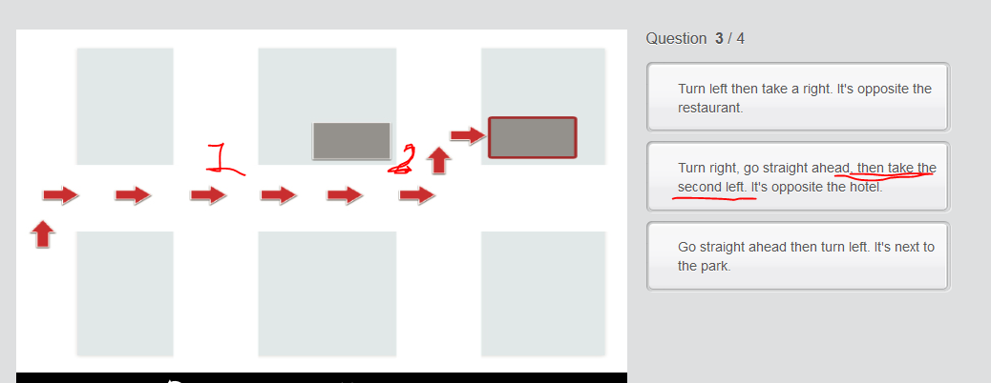  
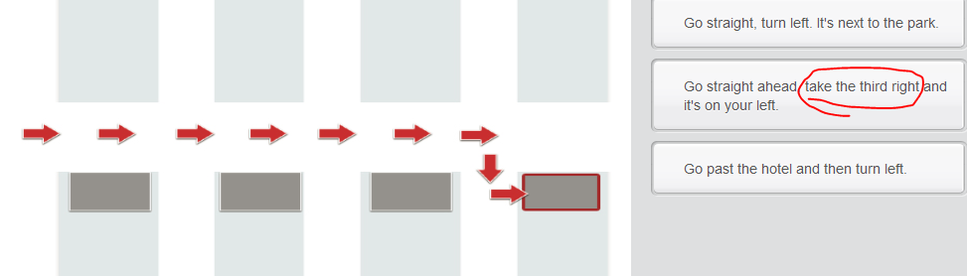

* “Happy to help, bye now”

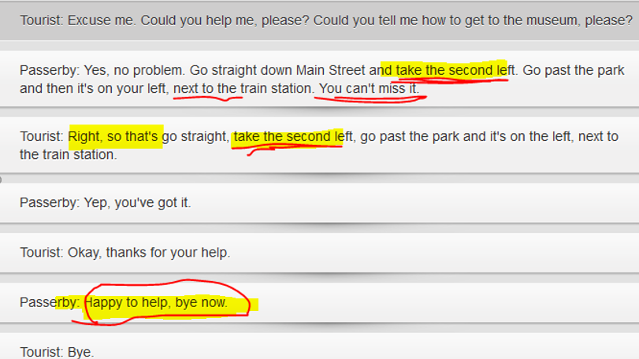

* **有轨电: tram**: a vehicle for passengers, which travels along metal tracks in the street
* subway = tube = underground => Metro station
* **〔内有舒适座椅的〕长途公共汽车**: coach: a bus with comfortable seats used for long journeys

•a coach trip to Scotland 去苏格兰的 长途公共汽车 之行

•The restaurant was full of coach parties (= groups of people travelling together on a coach ) . 这家饭店里用餐的全是乘长途公共汽车的旅游团。

**by coach** e.g. We went to Paris **by coach**. 我们**坐长途汽车**去巴黎。

on a coach e.g. She’s going to Grimsby on a coach. 她打算乘长途汽车去格里姆斯比

V.S. shuttle bus in the airport

## 1st row) Modes of transport

Which modes of transport do you prefer to travel by?

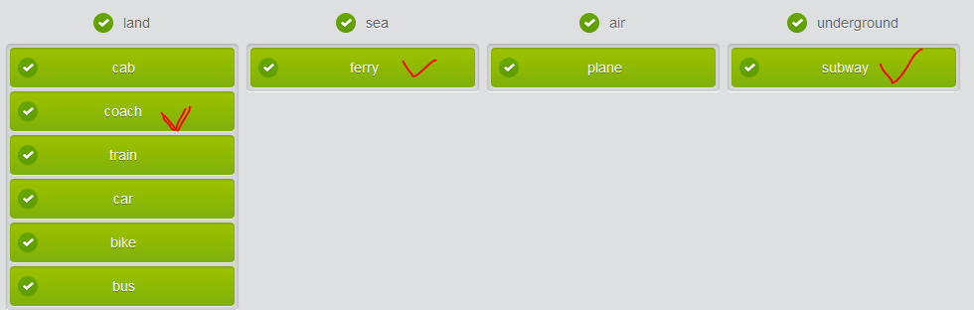

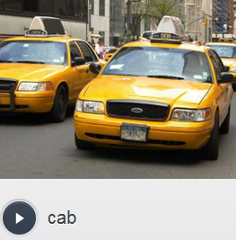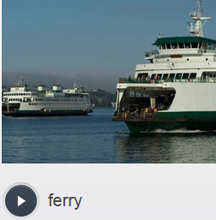

* 有轨电: tram a vehicle for passengers, which travels along metal tracks in the street

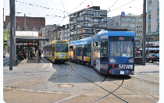

* subway = tube = underground => Metro station   
  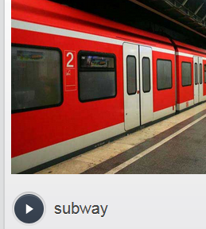 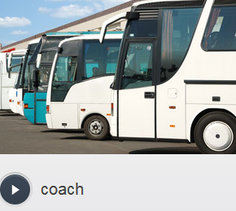
* 〔内有舒适座椅的〕长途公共汽车: coach: a bus with comfortable seats used for long journeys

•a coach trip to Scotland 去苏格兰的长途公共汽车之行

•The restaurant was full of coach parties (= groups of people travelling together on a coach ) . 这家饭店里用餐的全是乘长途公共汽车的旅游团。

by coach e.g. We went to Paris by coach. 我们坐长途汽车去巴黎。

on a coach e.g. She’s going to Grimsby on a coach. 她打算乘长途汽车去格里姆斯比

## 2nd row) Plane ticket

You are about to listen to someone booking a flight over the phone. Before you do so, practice some of the vocabulary from the dialogue.

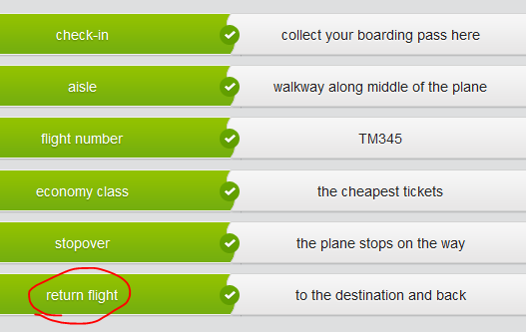 = round trip V.S. single trip

* direct flight V.S. **stop over** another city(transfer)
* aisle seat V.S. window seat
* return flight/round trip V.S. single trip: “Single or return?” or “Single or round”?
* economy class V.S. business class V.S. first class
* 

## Not mp3

TRACY: **Single or return ?**  
  
MATTHEW: Just single extra .  
  
TRACY: Let me just check the schedule... Yes, we have a flight on the 21st, departing 10am and arriving at 16:45pm. There’s also a cheaper flight with a **stopover** in Berlin, departing at 10.15am and arriving in Moscow at 18.05pm. Would you like to make a reservation?  
  
MATTHEW: Yes, please. I’ll take the **direct** flight.  
  
TRACY: Sure. Would you prefer **economy or business class**?  
  
MATTHEW: Economy (class) please . How much is that?  
  
TRACY: **The fare is $ 520.** Its peak season, I'm afraid. Would you prefer an **aisle or a window seat**?  
  
MATTHEW: I’d prefer an aisle seat.  
  
TRACY: No problem. Could you repeat your name?  
  
MATTHEW: Matthew Burke, B-U-R-K-E. What’s **the flight number**?  
  
TRACY: That’s TM345. Please **check in** at least one hour **s**.  
  
MATTHEW: Sure. Thanks for your help.

## STOP** 3rd row) Purchasing a plane ticket

Group the words according to whether they go with 'seat', 'class' or 'flight' when you’re purchasing a plane ticket

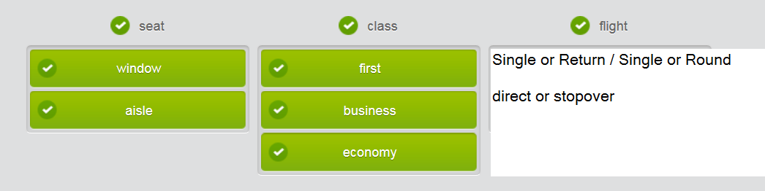

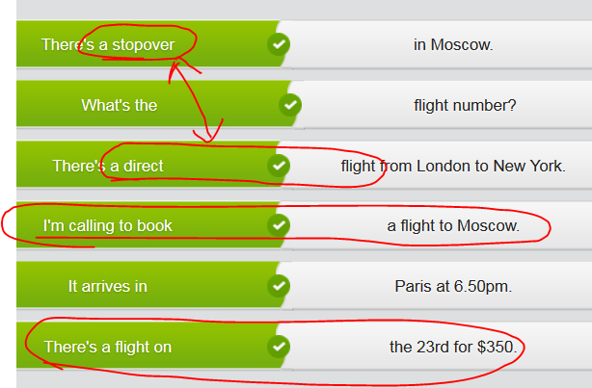

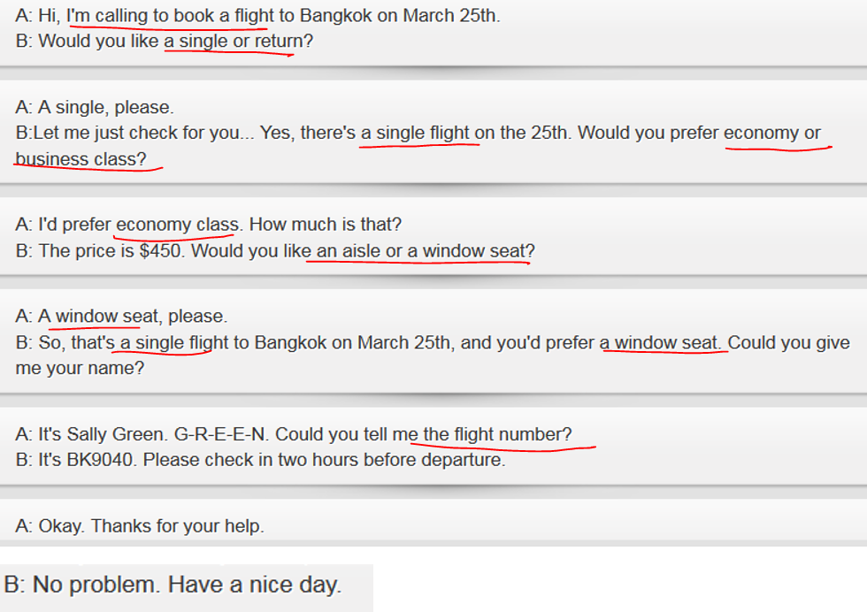

## Not mp3



## 4th row) Booking a flight

## Not mp3

You’re going on a business trip and have to book your ticket. Look at the information regarding your schedule and ticket then make the booking over the phone.

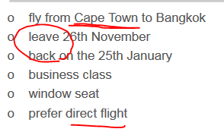

# Part 3) Asking for and following directions

## 1st) row Places in a town

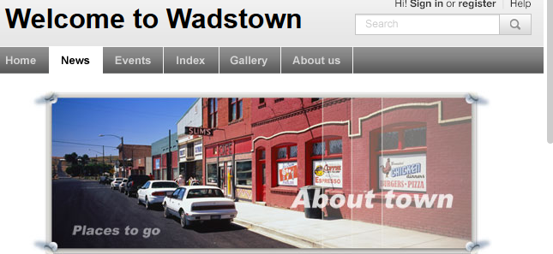

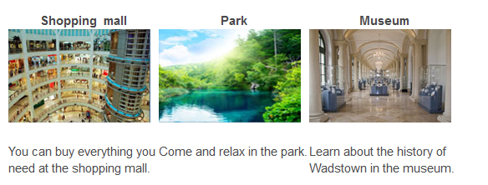

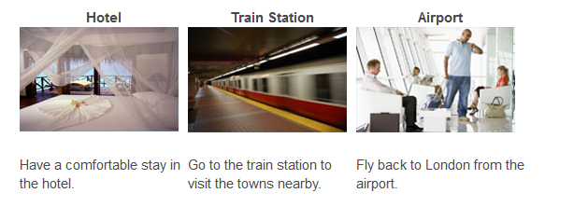

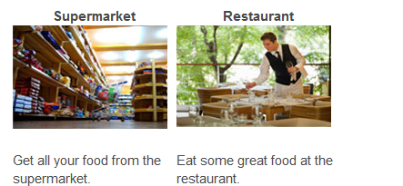

## 2nd row) Grammar: Prepositions of place

## Not mp3



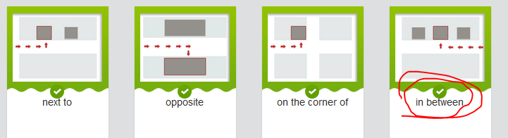

It’s on your right, **in between place A and place B.**

It’s **on the corner of streetA and streetB.** 在A街 和B街的交叉口

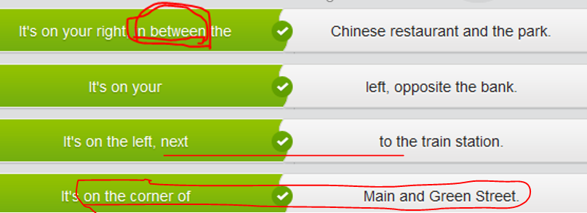

## Not mp3，3rd row)Ask for and following directions



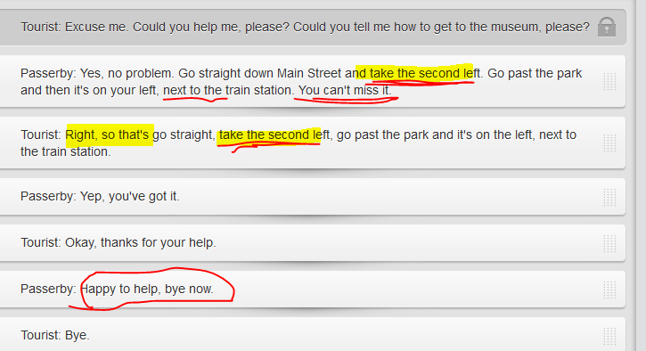

Tourist: Excuse me. Could you help me, please? **Could you tell me how to get to the** museum, please?  
  
Passerby: Yes, no problem**. Go straight down/along** Main Street and take the second left . Go past the park and **then it's on your left, next to t**he train station. **You can't miss it.**   
  
Tourist: **Right, so that's(just to repeat that person’s information for doublecheck😊** go straight, take the second left, go past the park and it's on the left , next to the train station.  
  
Passerby: Yep, you've got it.   
  
Tourist: Okay, thanks for your help.   
  
Passerby: **Happy to help, bye now**.   
  
Tourist: Bye.

## Not mp3，4th row)

On Main Street a tourist stops you to ask for directions to the bank. Consult the map you bought in the mall and give the tourist directions.

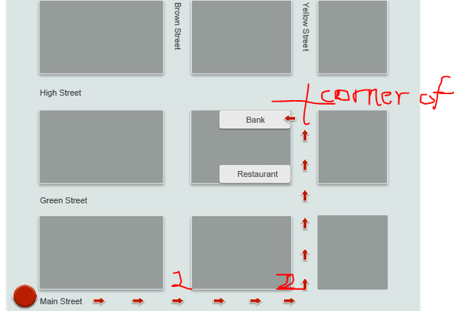

**Go straight down** the Main Street and **take the 2nd left/right.** Then **keep going ahead** till you pass a Chinese restaurant. The Bank is **on your left side, next to the** restaurant. More accurately**, it’s on the corner of Young Street and High Street. You can't miss it.**

# Part 4 )

## 1st) row) Kind of accommodation

**Holiday accommodations**  
  
When you travel, one of the first things you have to plan is where to stay. Most kinds of accommodation are generally called hotels, but there are different kinds for different needs. Here are some of the many choices.

|  |  |
| --- | --- |
| **Types of accommodation when travel** | **Comparison (should use “Venn diagram” for comparison, whole-to-whole; point-to-point (element of an object); similiarities-to-differences)** |
| * Hostel ['hɑstl] n. 旅社，招待所（尤指青年旅社）  1. a place where people can stay and eat fairly cheaply 〔提供廉价食宿的〕旅舍，招待所 2. a youth hostel 青年旅舍 | Hostels offer very basic services. You may share a bathroom and a room of single beds with other guests. Hostels are popular with budget travelers because of the low cost. |
|  |  |
| Inn | Some hotels in the US and UK are called inns, but they may be the same as other hotels or motels. In the UK, inns are sometimes older buildings that have served as a guesthouse for many years, and food and drink is served in a pub which is also used by locals. The prices are usually lower than in hotels. |
| Motel | Motels are like hotels but without special features. They are often used by travelers stopping to rest, and you can often drive right up to your door. Most motels are near major highways and cost less than a hotel. |
| Bed and breakfast / guesthouses /homestay    (like “homestay” OR **bungalow** /ˈbʌŋɡəˌləʊ/ : a bungalow is a house that has only one level, and no stairs. 平房 | Bed and breakfasts are usually large family homes that are used as guesthouses. They do not have the same features as a hotel, but you will have all the comforts of a real home, including a home-cooked breakfast. |
| Hotel | Basic hotels provide a room – bed, bath, desk and usually a TV – and sometimes have extras such as gyms, swimming pools and restaurants. The rooms are usually entered through a main lobby. Prices can vary from cheap to very expensive. |
|  |  |
| Resort [rɪ'zɔːt] | Resorts offer a beautiful setting and extra features such as swimming pools, private beaches, sports equipment, bars and restaurants. Expect to pay a bit more for a resort than a regular hotel. |

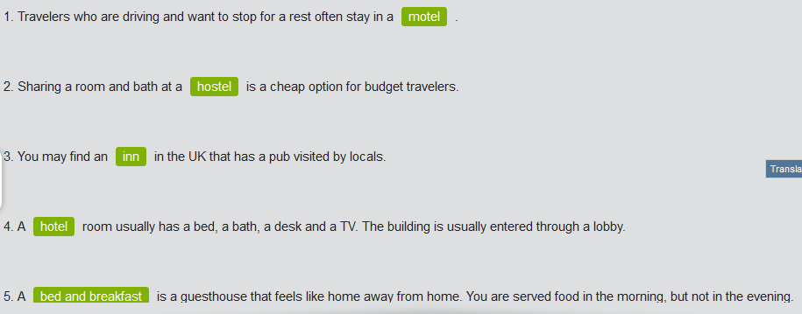



## Not map3) 2nd row) Hotel rooms and services



Listen to the dialogue between a hotel desk clerk [klɑːk] [klɝk] and a guest. // clerk is someone whose job is to help people when they arrive at and leave a hotel **〔旅店的〕接待员 [ the desk clerk酒店柜台服务员 ]**

DESK CLERK: Welcome to the Grand Hotel. **Do you have a reservation?**   
GUEST: Hello. No, but **do you have a room for tonight**?   
DESK CLERK: Yes, we do. What kind of room would you like?   
GUEST: A **standard room**, please. But I'm quite tall and I need a large bed.   
DESK CLERK: Most of our standard rooms have two **double beds**. We also have a room with one **queen-size bed**, but that would cost more. Or you can have **a suite with a king-size bed and a sofa**.   
GUEST: Could you tell me the price of the rooms?   
DESK CLERK: The **standard room** is $120, the **room with a queen-size bed** is $150, and the **suite** is $250.   
GUEST: I'd **like the room with the queen-size bed**, please.

## Types of room and bed in hotel

|  |  |
| --- | --- |
| Type of room | Standard room标间: normally with standard **double beds** or with one queen-size bed. |
| **[swiːt]** suite: a set of rooms, especially expensive ones in a hotel套房〔尤指酒店豪华套房〕  •a honeymoon suite 蜜月套房  •a suite of rooms for palace guests 王室贵宾套房 |
| Type of bed | **double beds** $120 |
| Queen-size bed: $140 |
| e.g. a suite**[swiːt]** 套房 normally include a king-size bed and sofa: $ 250 |

## Not map3) 3rd row) Making polite requests

## Not map3)

Listen to the second part of the dialogue between the hotel desk clerk and the guest. **clerk** is someone whose job is to help people when they arrive at and leave a hotel **〔旅店的〕接待员 [ the desk clerk酒店柜台服务员 ]**

## Make police requests from the hotel **desk clerk(酒店柜台服务员)**

* Can I have **a wake-up call**? = I’d like a wake-up call, is it OK? e.g. What time does he want his wake-up call?
* **I'd like** <some facilities>
  + **I’d like** a room reservation for three nights
  + **I'd like** a king-size bed.
  + **I’d like** a **wake-up call**. Is it OK?
  + **I’d like** a standard room with a queen-size bed.
  + I’m in business travel, so **I’d like a** suite with a king-size bed.
* I’d like to do sth
  + **I'd like to know if I could** check out late.
  + **I’d like to check out a little late, is that OK?**
  + **I’d like to check** in a little early, is that OK?
  + **I’d like to know if I could** check in a little early, is that OK?
  + **I’d like to know** whether the breakfast is included?
* May I check in early?
* Could you tell me when check-out time is?
* Could you tell me what facilities you have?
* **(One more thing)** Is it okay to use the gym/the business center?

## Not map3)

## Confirm your reservation in a hotel by mail or phone

Dear sir,   
  
**I would like to** confirm that I **have a reservation at the Grand Hotel for five nights,** that is from April 9-13. The reservation is for two people, so **I would like a standard room(标间) with 《double beds 》or a suite** . **Could you please tell me if** this reservation is confirmed?   
  
**Addtionally, could you also please t**ell me when the check-in time is? **I’d like to have an early check-in.**

One more thing**, I’d like to know if I could** check out a little late, let’s say, maybe 1 hr late at most.  
Thank you for your help. I can be contacted at this email address.   
  
Sincerely...

Phone: Hello, this is Tracy who has a reservation in xxx hotel. I’d like to confirm whether my conservation is there.

## 4th row) Making and confirming a reservation by phone

You are phoning a hotel to book a room. Read the notes to help you choose the most polite and appropriate answer to the **desk clerk(酒店的前台接待人员)** 's questions.

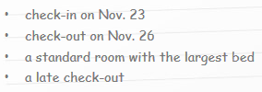

## Writing

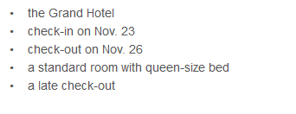

You haven't received a confirmation email from the hotel. Write a short email to confirm your booking. Use the text to help you. Write 50 - 70 words.

NOTE: Begin your email, 'Dear sir or madam,'

Dear madam,   
  
**I would like to** confirm that I **have a reservation at the Grand Hotel for 3 nights,** from Nov.23 to Nov.26. The reservation is for one people who is a little bigger, so **I would like a standard room with a queen-sized bed**. **Could you please tell me whether** this reservation is confirmed?   
  
One more thing**, I would like to know if I could** check out a little late, let’s say, maybe 1 hr late at most.  
Appreciate your help. I can be contacted at this email address.   
  
Sincerely...